================================ LEFT JOIN =====================================

{{{注意：JOIN并不保证联合后的表的数据的顺序，和原先的任意一个表的数据的顺序一致，可参见 特别的JOIN.docx}}}

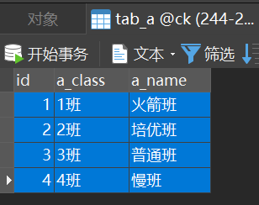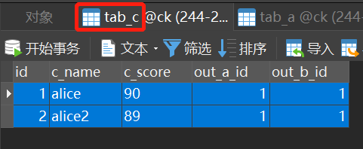

SELECT * FROM tab_a LEFT JOIN tab_c ON tab_a.id = tab_c.out_a_id;

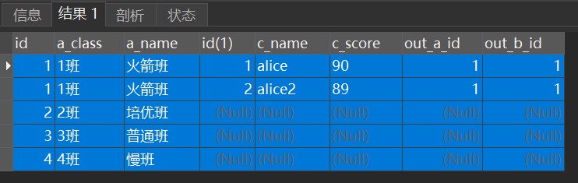

=================================INNER JOIN================================



SELECT * FROM tab_a JOIN tab_c ON tab_a.id = tab_c.out_a_id;

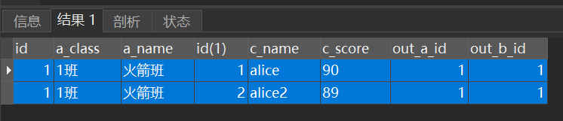

=============================== RIGHT JOIN==================================



SELECT * FROM tab_a RIGHT JOIN tab_c ON tab_a.id = tab_c.out_a_id;

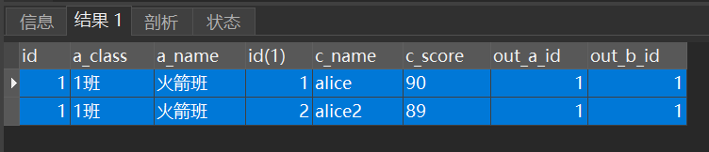

===============================RIGHT JOIN==================================

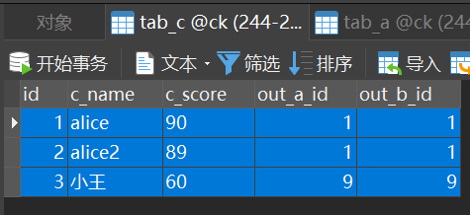

SELECT * FROM tab_a RIGHT JOIN tab_c ON tab_a.id = tab_c.out_a_id;

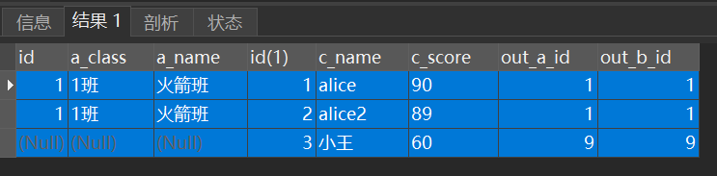

===================================多JOIN===================================

 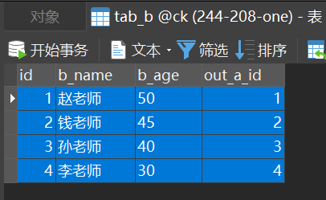



SELECT * FROM tab_a JOIN tab_c ON tab_a.id = tab_c.out_a_id JOIN tab_b ON tab_a.id = tab_b.out_a_id;

【SELECT * FROM tab_a JOIN tab_b ON tab_a.id = tab_b.out_a_id JOIN tab_c ON tab_a.id = tab_c.out_a_id; 换成这样写sql结果并无本质不同】

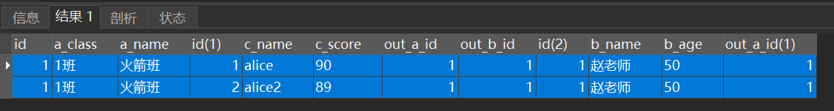

===================================JOIN后分组==================================

分组----------------------------------------------------------

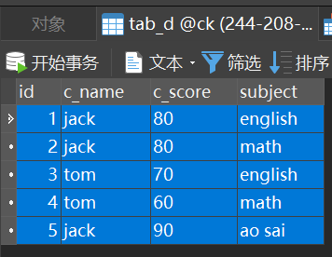

SELECT c_name FROM tab_d GROUP BY c_name;

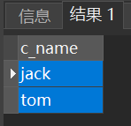

SELECT c_name, ANY_VALUE(c_score) FROM tab_d GROUP BY c_name;

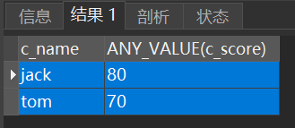

SELECT c_name, ANY_VALUE(c_score) FROM tab_d GROUP BY c_name, c_score;

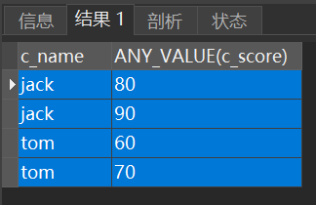

SELECT * FROM tab_d GROUP BY c_name, id; （由于c_name分组后组内又按id这个不重复列分组，故组内成员都会显示出来，也就无需在每个字段前加any_value了，故可以直接用 select *）【GROUP BY 后的c_name和id顺序不同分组的含义是不同的，后一个是前一个分组后的组内分组依据，SELECT * FROM tab_d GROUP BY id, c_name；的结果是不一样的】

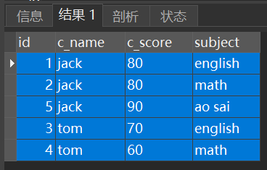

JOIN后的分组--------------------------------------------------------------------

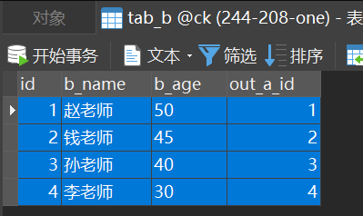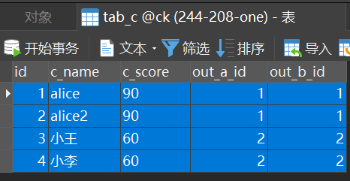

SELECT * FROM tab_b JOIN tab_c ON tab_b.id = tab_c.out_b_id;

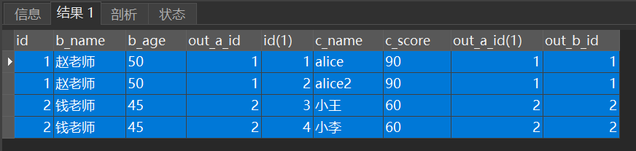

SELECT * FROM tab_b JOIN tab_c ON tab_b.id = tab_c.out_b_id GROUP BY tab_c.c_score,tab_c.c_name; 【分组的同时显示组内数据。】

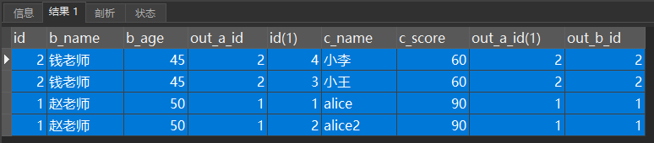

SELECT tab_b.b_name, tab_b.b_age, tab_c.c_name, tab_c.c_score FROM tab_b JOIN tab_c ON tab_b.id = tab_c.out_b_id GROUP BY tab_c.c_score,tab_c.c_name;

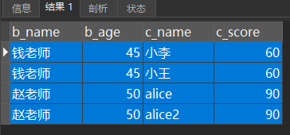

如果某些版本的MySQL报下面这样的错

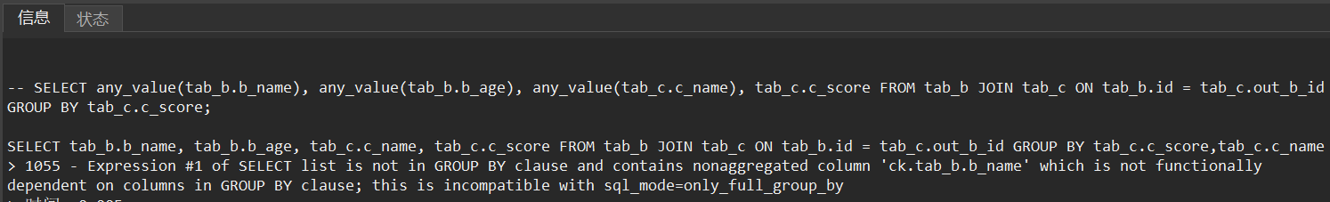

【报的错和SELECT * 是一样的---------1055 - Expression #1 of SELECT list is not in GROUP BY clause and contains nonaggregated column 'ck.tab_b.b_name' which is not functionally dependent on columns in GROUP BY clause; this is incompatible with sql_mode=only_full_group_by】

那就可以用这样的办法：--------------------------------------------

将GROUP BY中两个分组依据的第二个分组依据，即撑开组员而进行的组内分组的依据，改为id这种具备unique key、primary key属性的字段：

SELECT * FROM tab_b JOIN tab_c ON tab_b.id = tab_c.out_b_id GROUP BY tab_c.c_score,tab_c.id;

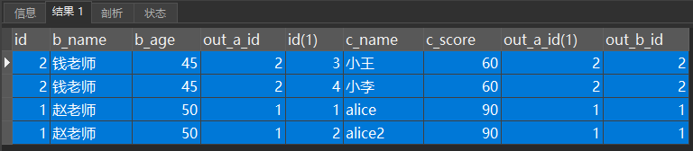

不过如果写成这样，结果有所不同，因为tab_b表的id在本次被JOIN后的是有重复的。

SELECT * FROM tab_b JOIN tab_c ON tab_b.id = tab_c.out_b_id GROUP BY tab_c.c_score,tab_b.id;

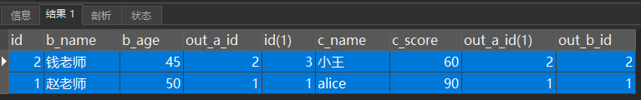

或者---------------（不推荐）---------------

SELECT any_value(tab_b.b_name), any_value(tab_b.b_age), tab_c.c_name, tab_c.c_score FROM tab_b JOIN tab_c ON tab_b.id = tab_c.out_b_id GROUP BY tab_c.c_score,tab_c.c_name;

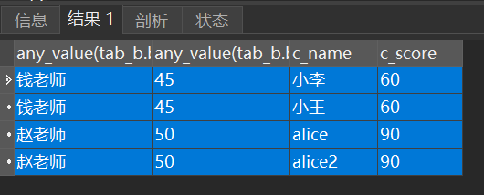

SELECT any_value(tab_b.b_name), any_value(tab_b.b_age), any_value(tab_c.c_name), tab_c.c_score FROM tab_b JOIN tab_c ON tab_b.id = tab_c.out_b_id GROUP BY tab_c.c_score;

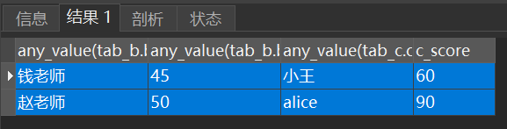

（完）